

**National University**



of Computer

and

Emerging Sciences

Chiniot

-

Faisalabad Campus



**Instructor:** Muhammad Adeel Tahir **EE1005 – Digital Logic Design**

**Quiz# 1**

|  |  |  |  |  |  |  |  |  |  |  |  |  |  |
| --- | --- | --- | --- | --- | --- | --- | --- | --- | --- | --- | --- | --- | --- |
| **Name**: |  | | **Section:** | CS - N | **Roll Number** |  |  |  | **-** |  |  |  |  |
| **Total Marks:** | 40 Marks | **Total Time:** | 40 mins | | **Marking (do not fill these)** |  |  |  |  |  |  |  | |
| **Obtained Marks** |  | | | | | | | | | | | | |
| * Questions must be solved in the space provided for them, incase answers are not in the respective fields, they will not be marked * Use extra rough sheets or spaces provided for your rough works, do not make a mess on the solution areas. * MCQ questions must not have any cutting whatsoever, if more than one option is marked, it will be marked as incorrect. * Only use permeant ink pen for marking your answers, answers written with pencils will not be checked. | | | | | | | | | | | | | | |

**Multiple Choice Questions: *Circle the correct option*** or options (if more than one is correct) for the following questions. Once marked, any cutting will lead to 0 mark for the MCQ. **[10 marks]**

**1. The given hexadecimal number (1E.53)16 is equivalent to:**a) (35.684)8  **b) (36.246)8** c) (34.340)8 d) (35.599)8

**2. The octal number (651.124)8 is equivalent to ______  
a) (1A9.2A)16** b) (1B0.10)16 c) (1A8.A3)16 d) (1B0.B0)16

**3. Binary subtraction of 101101 – 001011 = ?  
a) 100010** b) 010110 c) 110101 d) 101100

**4. The binary number 10001101010001101111 can be written in hexadecimal as**

(a) AD46716 b) 8C46F16  **c) 8D46F16** (d) AE46F16

**5. On subtracting (010110)2 from (1011001)2 using 2’s complement, we get ____________**a) 0111001 b) 1100101 c) 0110110 **d) 1000011**

**6, On addition of +38 and -20 using 2’s complement, we get ____________**a) 11110001 b) 100001110 **c) 010010** d) 110101011

**7. An overflow occurs in _________  
a) MSD position** b) LSD position c) Middle position d) Signed Bit *(MSD|LSD , D refers to digit)*

**8. The advantage of 2’s complement system is that _________  
a) Only one arithmetic operation is required** b) Two arithmetic operations are required

c) No arithmetic operations are required d) Different Arithmetic operations are required

**9. For arithmetic operations only _________**  
a) 1’s complement is used **b) 2’s complement** c) 10’s complement d) 9’s complement

**10. The excess-3 code for 597 is given by __________  
a) 100011001010**  b) 100010100111 c) 010110010111 d) 010110101101

**Answer Box (mark the correct letter i.e a,b,c,d in SEQUENCE)**

|  |  |  |  |  |  |  |  |  |  |
| --- | --- | --- | --- | --- | --- | --- | --- | --- | --- |
| **b** | **a** | **a** | **c** | **d** | **c** | **a** | **a** | **b** | **a** |

**For Rough Work Only**

**Question 1:** Convert the decimal number **97.710** into a number with the same value represented in the following bases. The exact value requires an infinite repeating part in the fractional part of the number. Show the steps of your derivation.

(a) binary (b) octal (c) hexadecimal (d) base 3 (e) base 5 **[1+1+1+1+1+3 = 8 marks]**

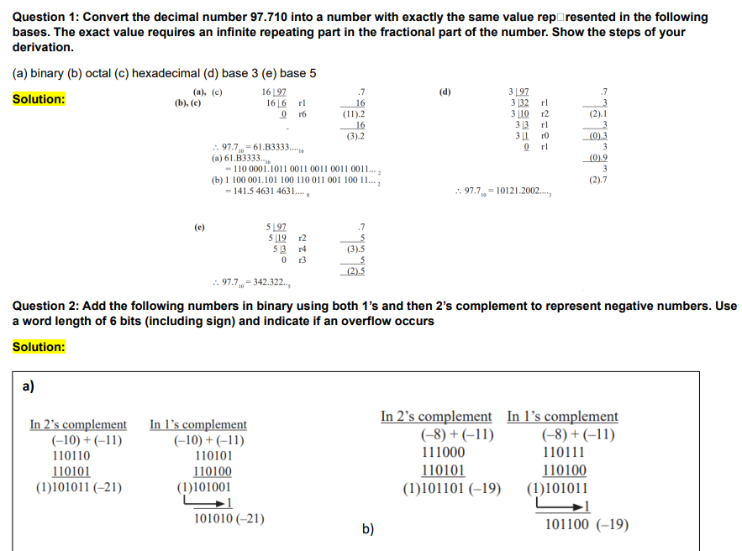

**Convert (641/3)5 to Hexadecimal. (if possible**) **[3 marks]**

[(43)1/3]5

= (4)5 🡺 ?16

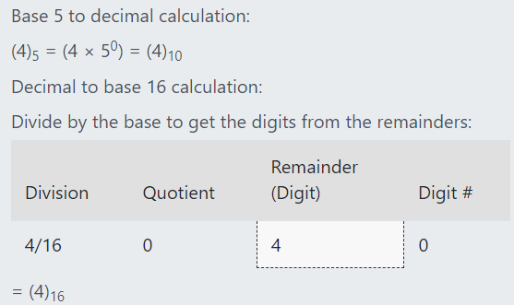

**Question 3:** One of the following bit patterns is valid BCD (binary-coded decimal), but the other one is not, Which one is not valid? For credit to be given, you must give a correct reason. **[2 marks]**

**1. 100110110100**

**2. 100100111000**

**Which one is valid? 2nd one**

**Why is the other one not valid:**

**In BCD, each 4-bit group (nibble) represents a decimal digit from 0 to 9. Each nibble must be between 0000 and 1001.**

**Breaking down the given bit pattern into nibbles:**

1. **1001**
2. **1011**
3. **0100**

**The second nibble, 1011, is not a valid BCD representation, as it exceeds the maximum value of 1001. Therefore, the entire bit pattern is invalid.**

**Question 4:** Find the 9's and the 10's complement of the following decimal numbers: **[4 marks]**

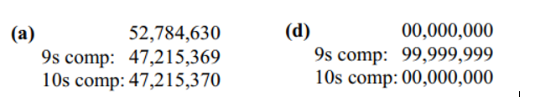

**Question 5**: Add the signed numbers: 01000100, 00011011, 00001110, and 00010010 and write your final answer in the provided space. **[2 marks]**

|  |  |  |
| --- | --- | --- |
|  | |  |
| **Final Answer:** | (In Binary): 01111111 | (In Decimal): 127 |

**Question 6:** Add the following BCD numbers: **[2 + 2 = 4 marks]**

|  |  |
| --- | --- |
|  |  |

**Question 7** Gray code conversions. Attempt the following parts carefully. **[1+1+2 =4 marks]**

|  |  |
| --- | --- |
| (a) Convert the binary number 11000110 to Gray code | (b) Convert the Gray code 10101111 to binary. |
| (c) The ten-bit Gray code for (353)10 is 0111010001. Explain briefly but precisely why it cannot be true that 0111010100 is the ten-bit Gray code for (354)10.  **Also calculate gray code for 35410**  **Gray Code for (354)10 :**  111010011 | **Explanation:**  In Gray code, consecutive numbers differ by only **one bit.**  Given that the Gray code for 353₁₀ is 0111010001, the Gray code for 354₁₀ must differ by **exactly one bit**.  If we compare 0111010100 to 0111010001, we see that **two bits** are different (positions 8 and 2). **This violates the fundamental property of Gray code.**  **Therefore, 0111010100 cannot be the correct Gray code for 354₁₀.** |

**Question 8:** Construct a 6-2-2-1 weighted code for decimal digits. What are all possible combinations through which the 982310 can be constructed using the weight in 6-2-2-1? **[4 + 3 = 7 marks]**

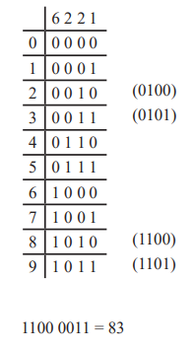

Different Combinations to represent **982310**

**Digit 9 in 6-2-2-1 weighted code: 1011**

**Digit 8 in 6-2-2-1 weighted code: 1010**

**Digit 2 in 6-2-2-1 weighted code: 0010**

**Digit 3 in 6-2-2-1 weighted code: 0011**

there were other combinations as well one is written here for simplicity:

1101 (9) 1100 (8) 0100 (2) 0101 (3)

… and so on.

**If 4 written correctly , full marks are awarded.**

**FOR ROUGH WORK ONLY (will not be checked):**